**Executive Summary: Bank Churn Analysis**

This project analyzes customer churn using SQL queries on the Bank_Churn_Cleaned dataset. The objective was to identify categories with the highest churn, calculate total churned customers, and provide deeper insights into churn behavior based on demographics and financial indicators.

**Key Findings:**

1. **Churn by Category**
   * Geography, Gender, Tenure, Number of Products, Credit Card ownership, and Active Membership were analyzed to see which groups have the highest churn rates.
   * Initial results show notable churn concentration in certain geographies and among inactive members.
2. **Total Churn**
   * Out of 10,000 customers, a total of *2037* customers exited the bank.
3. **Customer Base Size**
   * The dataset covers all 10,000 customers, of which ~20% churned.
4. **Range-Based Churn Analysis**
   * **Credit Score:** Customers with lower credit scores (<650) showed higher churn rates.
   * **Age:** Middle-aged customers (40–50) churned more compared to younger or older groups.
   * **Balance:** Both customers with *zero balances* and very high balances showed distinct churn patterns.

**Conclusion:**  
The SQL analysis provides a foundation for understanding churn drivers. These insights will be further visualized in Power BI to highlight trends and guide retention strategies.

**Bank Churn SQL Queries**

1. Churn by Category:

**Geography**

select Geography, count(*) as Churn_Count_by_Geography

from Bank_Churn_Cleaned

where Exited = 1

group by Geography

order by Churn_Count_by_Geography desc;

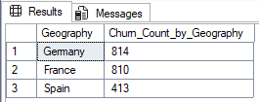

**Gender**

select Gender, count(*) as Churn_Count_by_Gender

from Bank_Churn_Cleaned

where Exited = 1

group by Gender

order by Churn_Count_by_Gender desc;

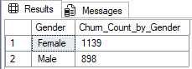

**Tenure**

select Tenure , count(*) as Churn_Count_by_Tenure

from Bank_Churn_Cleaned

where Exited = 1

group by Tenure

order by Churn_Count_by_Tenure desc;

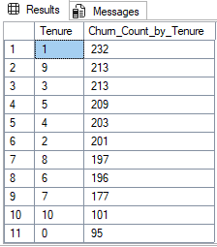

**Number of Products**

select NumOfProducts , count(*) as Churn_Count_by_NumOfProducts

from Bank_Churn_Cleaned

where Exited = 1

group by NumOfProducts

order by Churn_Count_by_NumOfProducts desc;

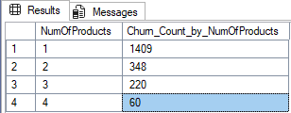

**Credit Card Ownership**

select HasCrCard, count(*) as Churn_Count_by_HasCrCard

from Bank_Churn_Cleaned

where Exited = 1

group by HasCrCard

order by Churn_Count_by_HasCrCard desc;

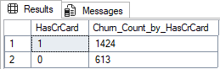

**Active Membership**

select IsActiveMember, count(*) as Churn_Count_by_IsActiveMember

from Bank_Churn_Cleaned

where Exited = 1

group by IsActiveMember

order by Churn_Count_by_IsActiveMember

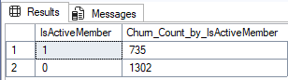

1. Total Number of Churned Customers

select count(*) as Total_Churned_Customers

from Bank_Churn_Cleaned

where Exited = 1;

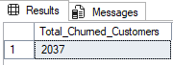

1. Total Number of Customers

select count(Exited) as Total_Number_of_Customers

from Bank_Churn_Cleaned;

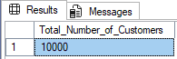

**Churn by Ranges**

1. Credit Score Ranges

SELECT

CreditScoreRange,

COUNT(*) AS total_customers,

SUM(CASE WHEN Exited = 1 THEN 1 ELSE 0 END) AS churned_customers,

SUM(CASE WHEN Exited = 0 THEN 1 ELSE 0 END) AS retained_customers

FROM (

SELECT

CASE

WHEN CreditScore < 500 THEN '<500'

WHEN CreditScore BETWEEN 500 AND 650 THEN '500-650'

WHEN CreditScore BETWEEN 651 AND 750 THEN '651-750'

WHEN CreditScore BETWEEN 751 AND 850 THEN '751-850'

ELSE '>850'

END AS CreditScoreRange,

Exited

FROM Bank_Churn_Cleaned

) AS t

GROUP BY CreditScoreRange

ORDER BY CreditScoreRange;

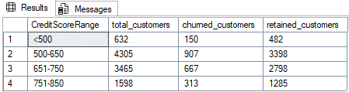

1. Age Ranges

SELECT

AgeRange,

COUNT(*) AS total_customers,

SUM(CASE WHEN Exited = 1 THEN 1 ELSE 0 END) AS churned_customers,

SUM(CASE WHEN Exited = 0 THEN 1 ELSE 0 END) AS retained_customers

FROM (

SELECT

CASE

WHEN Age < 30 THEN '<30'

WHEN Age BETWEEN 30 AND 40 THEN '30-40'

WHEN Age BETWEEN 41 AND 50 THEN '41-50'

WHEN Age BETWEEN 51 AND 60 THEN '51-60'

ELSE '>60'

END AS AgeRange,

Exited

FROM Bank_Churn_Cleaned

) AS t

GROUP BY AgeRange

ORDER BY AgeRange;

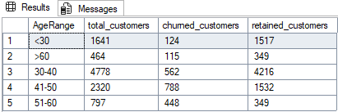

1. Account Balance Ranges

SELECT

BalanceRange,

COUNT(*) AS total_customers,

SUM(CASE WHEN Exited = 1 THEN 1 ELSE 0 END) AS churned_customers,

SUM(CASE WHEN Exited = 0 THEN 1 ELSE 0 END) AS retained_customers

FROM (

SELECT

CASE

WHEN Balance = 0 THEN '0'

WHEN Balance BETWEEN 1 AND 50000 THEN '1-50K'

WHEN Balance BETWEEN 50001 AND 100000 THEN '50K-100K'

WHEN Balance BETWEEN 100001 AND 150000 THEN '100K-150K'

ELSE '>150K'

END AS BalanceRange,

Exited

FROM Bank_Churn_Cleaned

) AS t

GROUP BY BalanceRange

ORDER BY BalanceRange;

